County Highlights August 2020

Dear all

A mini “Highlights” to update you with some news prior to the start of our autumn term. We hope that you have been able to enjoy some of the hot, balmy weather we have been having. For both of us, it’s a bit too hot!

Face to Face meetings
A few units have been able to meet face to face outdoors following the new guidance from Girlguiding. All the information about how to do this safely is on the Girlguiding website along with a template risk assessment which will need completing. Do ask your commissioner for help if necessary. The process is new to us all!

Whilst we await news of when we can return to indoor meetings, you may wish to consider starting to plan the autumn term using virtual guiding. Hints and tips can be found in the Webinars (accessed by logging into GO and searching under the Learning Opportunities tab). Alternatively, reach out to others in your district and see what they have been doing (many leaders have offered to “buddy” anyone interested in seeing what virtual guiding is like). Look out for Region section events later in August to help leaders plan

The Adventures at Home resource will continue to be offered nationally and this can be used by anyone if planning outdoor or virtual meetings is not an option.

If you anticipate any difficulty with being able to return to face to face indoor meetings when we are allowed to (such as a change in the unit team, venue no longer being available, financial limitations), do let your commissioner know so they can help you explore the support options available.

Subscriptions
The fees a unit charges usually cover 2 things, the annual Girlguiding membership fee, which will have levies from CHQ, Region, County and sometimes Division and/or District and the unit’s running costs. Your unit costs may be reduced because you are not meeting. For some, there will be on-going costs they still have to meet. Virtual meetings are not necessarily without cost either. In preparation for the new term, please take some time to consider what fee to charge parents this autumn. As a minimum, there will still be the annual memerbship cost to meet next year. Letter templates are available on the Girlguiding website to help communicate this to parents.

Comfort bags – who knew….this can be a virtual activity too! 60 more comfort bags have been donated from Goostrey Guides who have continued to meet over the summer. We are particularly short of combs and deodorant at the moment. Do get in touch with Rachel Robinson via comfortbagpictures@gmail.com if you have donations or would like more information about this.

1st Response Nationally, St John Ambulance have started back some face to face trainings and we are awaiting news about when and where our trainers will be able to safely restart. Girlguiding led training is being trialled as a combination of webinar and practicals but, as yet this is not widely available. This must be very frustrating for those waiting to complete their LQ. Be assured, we are doing all we can to find a solution.

DBS Checks within current social distancing guidance DBS checks can now be completed. If yours is due and you haven’t heard from your DC or local ID verifier then please give them a nudge to make arrangements.

Finally, we have been touched by your kind responses to the badges and cards that we sent out. If for some reason you didn’t receive your Together at Heart badge, do get in touch.
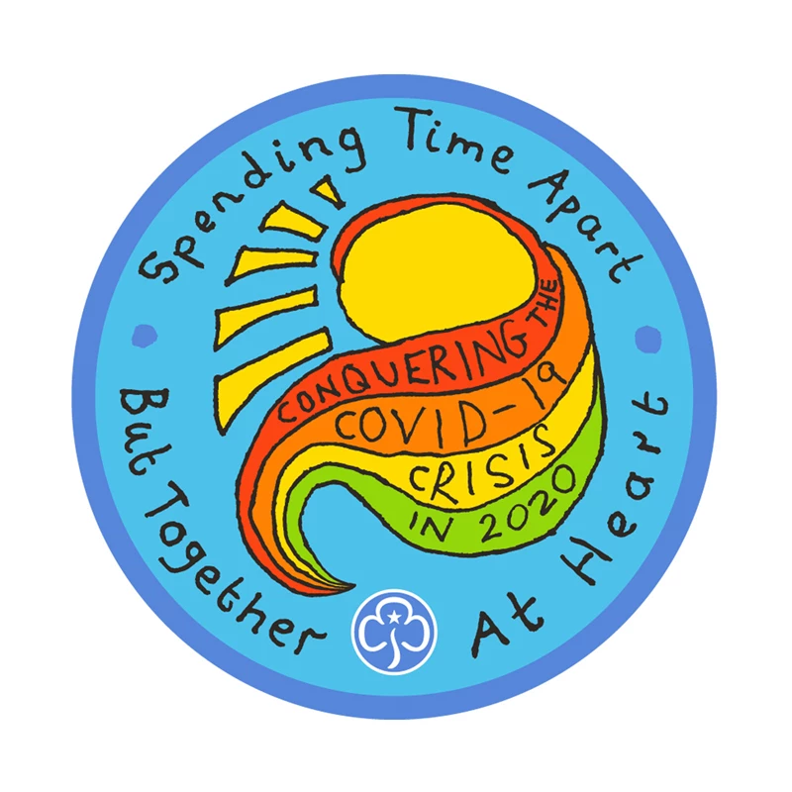
Yours in Guiding

Karen and Linda

Karen email countycommissioner@girlguidingcheshireborder.org.uk
Linda email asstcc@girlguidingcheshireborder.org.uk

